Constant, continuous change

Author
Melanie Franklin
Director
Agile Change Management Limited

Introduction
I have been leading transformational change programmes for over 20 years, and during this time I have seen the environment in which we work shift from implementing singular change to coping with a relentless stream of change.

We are bombarded by new ideas, expected to change what, how, when, with whom we are currently working, and adapt to these changes intuitively. When our ways of working continually evolve, it can feel as if we are on a treadmill that never stops. No runner can run for infinity so why do we think it is possible at work? Of course it isn't, which is why we talk about stress and burn-out and why people leave their jobs even if they don't have another to go to.

This paper explores the impact of the new change environment and makes suggestions for how we can address the challenges we face. As with everything, the ideas in this paper are constantly evolving, and you are welcome to share your thoughts on the scope of the problem and how it can be addressed through the Continuous Change Community.

Why have we reached saturation point?
We are at saturation point with the number of changes that we are attempting to implement simultaneously. I have heard this issue raised as a risk by many organisations in disparate industries and countries. Heads of Transformation and Change, those in the PMO and those responsible for operational leadership are concerned about change fatigue, or as one of my contacts described it “we are running our people too hot and we have been doing it for too long”.

Agile approaches
The adoption of Agile approaches has increased the volume of change three, four or five fold in comparison with more traditional “waterfall” approaches. This is because change becomes ready for adoption early and frequently throughout the life of the initiative, instead of all change being packaged together for implementation at the end of the initiative.

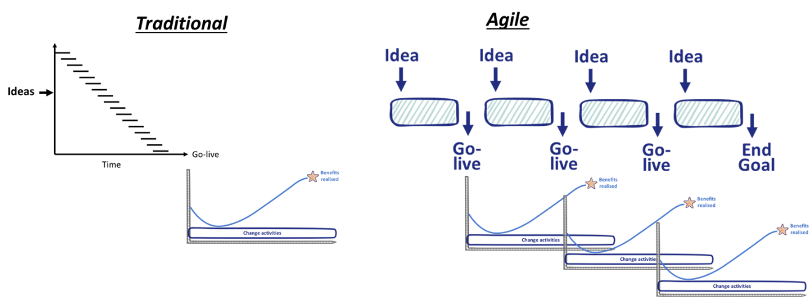
Source: Melanie Franklin 2020

This pressure is not going to go away, PMI Pulse of the Profession 2020 found that organisational agility was cited by 35% of executive leaders as key to achieving success in this disrupted world.

Interconnected change

Change doesn’t respect organisational boundaries, a change directed at one area of the business can involve many other teams and departments with shared systems, clients, suppliers, and data.

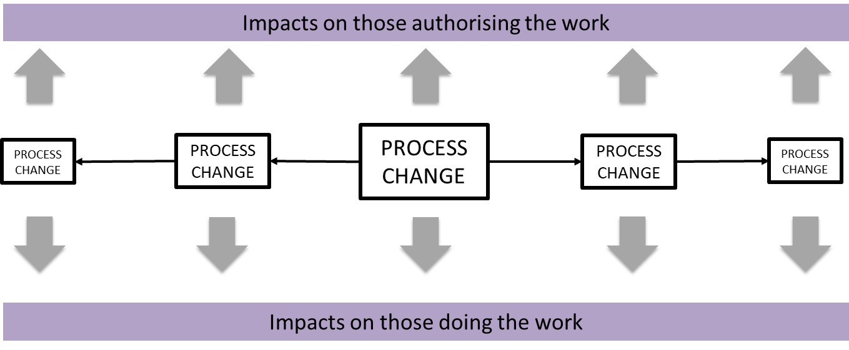
Source: Melanie Franklin 2020

The high volume of change is driven by the domino effect, where one change in process can trigger further changes upstream and downstream. Enterprise-wide systems, shared data, adoption of organisation-wide “best practices” have created a hyper connected environment. Change in any part of the environment triggers ripple effects, causing additional unplanned stress.

Challenge for the Change Management profession

Update our models
The body of work that supports the change management profession addresses how to manage a singular change for a clearly defined group of stakeholders. In our new reality, we need more than a mechanism for leading a single change, we need an approach for navigating all the changes impacting how we work.

Whilst I find value in models including Bridges Transition, Kotter’s 8 steps, Lewin’s 3 steps of change, I believe the time has come to look our approach through a new lens. We need mechanisms to manage the ripple effects, calculating the total impact of all changes and assessing the how close to breaking point our staff really are.

This means starting each change initiative from the perspective that it is part of an interconnected web of other changes and improvements, and understanding this alignment is the first task. Our techniques for Impact Assessment and Readiness Assessment must be expanded to include the effects of these other changes. I no longer create my Change Plan for one change, instead I try to show the activities for implementing one change whilst also including activities taking place from other change initiatives so that I am always conscious of the sum total of effort required from those in the business areas impacted.

This makes my job so much more difficult than it was before and shifts where I spend my time. I now find that I need to integrate and align my work with so many others than it is my alliance building and interest in their progress that makes the difference between success and failure.

I think we are only just scratching the surface with these issues, and we need to come together as a profession to solve the problems of inter-connectedness.

Address the fundamentals
If we are to achieve our goals for effectively managed change, we need to address the biggest impediments to change:
- Not enough people to meet the needs of maintaining busines as usual whilst making significant changes to ways of working.
- Failure to prioritise all change initiatives against business need.

Resource issues
However committed staff are to adopting a new way of working, the time and effort needed to help design it and practice the new approaches are impeded by their need to also support business as usual at the same time. Up to about 5 years ago, I think staff could just about cope with being asked to do things on top of their existing workload.

Leaders assumed that everything could be covered by the “ever expanding working day” when people would come in early, leave late and work through lunch and at weekends to make things happen. I don’t think we are suffering from a loss of this type of commitment, I think we have hit a structural problem: there is no more time left. The extended working day principle could work when one or two change projects required support, but the high volumes of change impacting us today makes this impossible.

We have to get serious about explicitly planning and assigning resources to make change happen, and this has to be addressed up front, before money is spend on via the project budget on the tangible change, assuming someone will be available at the end to put the deliverable into operational use.

Prioritisation
The level of additional effort we demand from staff to implement change requires significant intrinsic motivation. A key ingredient of this motivation is the belief that what they are being asked to work on has value and meaning. Therefore, this motivation significantly decreases if staff feel they are being asked to work on “vanity” projects, where someone with authority has decided something has to change, possibly connected to their interests or objectives. Motivation comes from demonstrating a clear line of sight between making the change and achieving benefits.

This means we need to assess all our ideas against business need, and clearly establish that our scarce human resources are being asked to work on only the most valuable initiatives.

Increase our skills in behavioural change
I also think we need to broaden the scope of professional change management to include much greater emphasis on encouraging and supporting behavioural change. This includes but is not limited to:
- Understanding how our brains react to messages about change and disruption to existing patterns of work.
- Using the research from positive psychology to create environments which encourage and support creativity in finding new ways of working.
- Building emotional resilience in ourselves and all those impacted by change.

Coping mechanisms for organisations

Create an integrated approach
I think our first action must be to correctly scope the management of change. Change starts with the creation and implementation of tangible change, the outputs and deliverables from projects and programmes. This is followed by work to accept the need for new ways of working and the creation of new routines and habits that incorporate these deliverables into new ways of working.

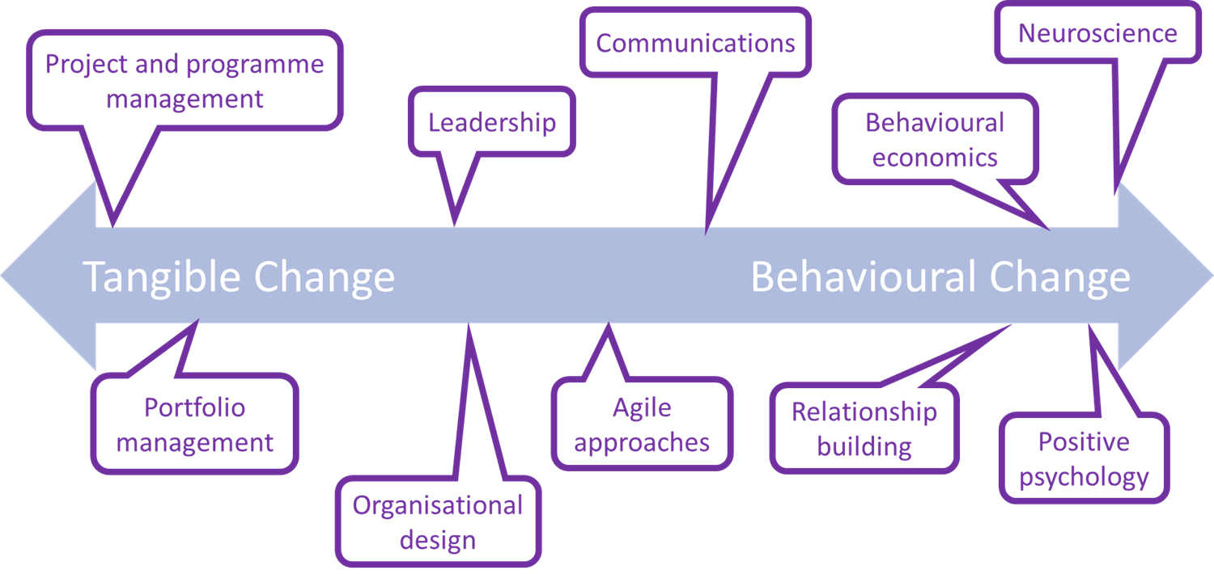
Source: Melanie Franklin 2020

By adopting this broad scope, we can correctly identify the variety of resources and skills needed to make change happen. On the left we have established management disciplines, and on the right the elements that support shifts in behaviours and attitudes which lead to shifts in how things are done.

Make change a leadership issue
To manage a very high volume of simultaneous change, I think we need to broaden the scope of our profession, building a stronger alliance with our colleagues in Portfolio Management, Project and Programme Management, Benefits Management and the strategy or strategic planning function within our organisations.

Too often, there are turf wars, with different management disciplines claiming they are the right function to lead the organisational change effort. I think we should turn this on its head and realise that all these management disciplines are core to effective leadership.

I want to work for organisations where change management is a core leadership skill, and leaders draw from other disciplines whatever help and support they need to make change happen. We can only achieve this “pull” mechanism if we more clearly and more frequently state the value of change management. If what we do is recognised as business value, leaders will not want to develop change management skills.

Draw multiple changes into a cohesive picture
Increase the value and therefore strengthen the purpose motive by looking beyond the benefits of a single change, by aligning it to other changes. Use your knowledge of other things that have changed recently and things that are likely to come up in the near future to put the change into a wider context. I have a template for communicating change that includes the following fields:
- How does this change relate to changes that have already taken place over the last 6-12 months?
- How does this change relate to changes that are currently taking place?
- How does this change relate to other ideas that are currently being discussed and that staff might have heard about?
By relating one change to other changes, it creates a cohesive view of what is happening, and reduces mis-trust as staff don't feel as if everything they are being asked to do is going off at tangents and doesn't connect. This cohesive picture increases the feeling that each change is building on others and so is more worthwhile that if looked at in isolation.

Totality of impact
Heat mapping is nothing new, but I think we need to ask questions that assess not just the structural impact on functional areas of the business, but also start to question how much staff are feeling about the level of disruption they are experiencing and their ability to cope.

Although this is subjective, I use this equation to generate a conversation about how people are feeling, with a simple traffic light scoring system so I can see where we are close to burn-out.

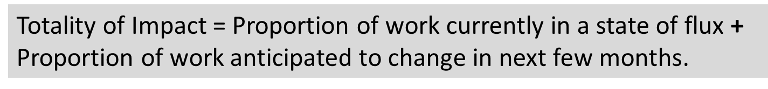
Source: Melanie Franklin 2020

Greater emphasis on inter-dependencies
Too often, we assess the change in light of the immediate procedural changes that it triggers. This gives the impression that we understand the knock-on effects of making change in one area, and helps us address those stakeholders that will be affected by our change.

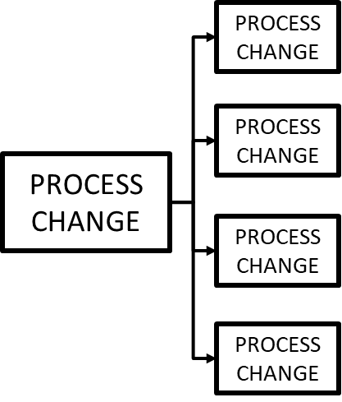

However, when so many elements of our business are inter-connected, I think we must go further, widening our impact assessment from “immediate” stakeholders to “impact on my stakeholders’ stakeholders”.

As the “domino effect” of these multiple impacts are identified, there needs to be a process of negotiation and compromise to ensure that progress with one initiative does not prevent progress with other initiatives.

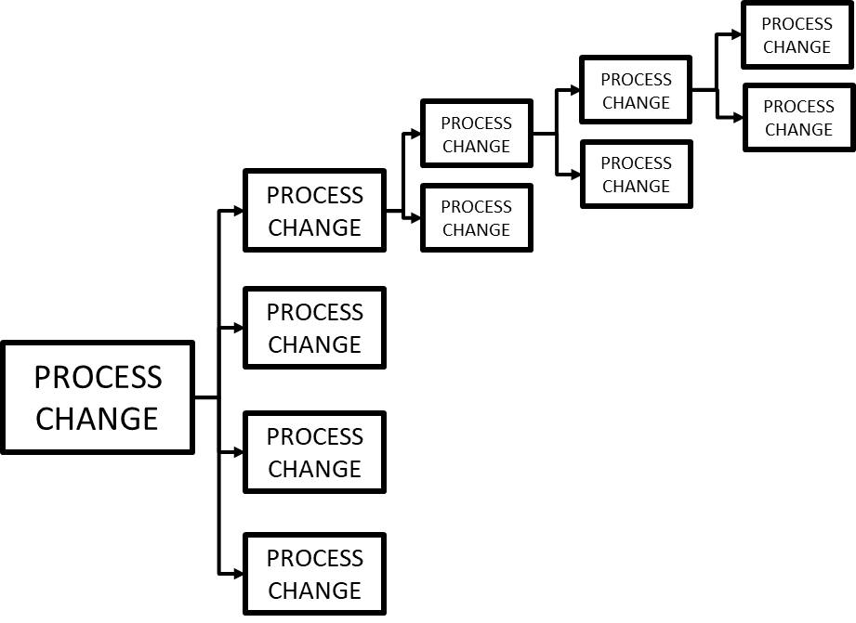

From my own experience, this has necessitated the bringing together of project and programme managers to present their plans, highlight the knock-on effects to other initiatives and then undertake “horse-trading” where different initiatives delay or accelerate activities to better fit with the needs of their colleagues and the impact on business as usual. This is a complex process which needs to be undertaken regularly, at least quarterly.

Coping mechanisms for individuals
Change is exhausting mentally and emotionally, so we need as much help as possible to “lighten the load”. These techniques come from my course on using brain short-cuts to achieve behavioural change. They are simple, effective techniques, grounded in neuroscience and the school of positive psychology to help us strengthen our emotional resilience.

De-personalise the situation
This technique uses the power of language to help us gain a more positive perspective of our situation. This positivity decreases our stress, creating capacity in our brains to develop new solutions.

When we face a difficult situation, we need to change our view of it, removing the negative emotions by reframing how we describe what we are experiencing. This is because our internal voice can have a powerful effect on how we feel and our ability to cope.

For example, instead of describing how you feel as “I am overwhelmed”, change the description to de-personalise it using the phrase “this is overwhelming”. A small change of words changes the meaning:
- “I am” makes it the situation feel as if it were all on our shoulders, leading to stress and panic.
- “This is” defines the situation objectively, this distance allows us to stand back and work out a solution.
Try it for yourself, it is a quick and powerful tool for creating breathing space between yourself and the problem you are experiencing.

Stock take
Too often in change, we are under so much pressure from the volume of activities we are responsible for, we don’t spend time thinking about what we have achieved. Instead, all we can see ahead of us is what is not yet done. This never-ending list of things we have not yet accomplished creates a low-level but persistent level of stress which in neuroscience terms is described as maladaptive. This means that

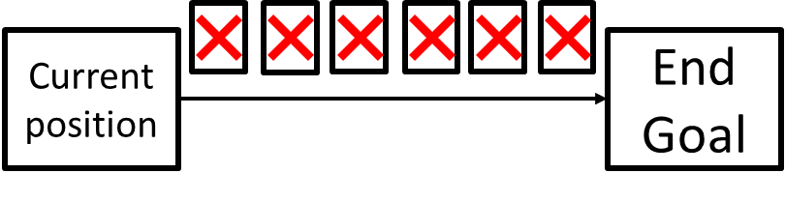

We need to look at the present and identify our achievements rather than focusing on the future and all the things we have not yet done. When change never ends, looking at the things not yet done means we steal away any chance of celebrating an accomplishment. We do not stop and congratulate ourselves for the progress we have made. How can we, we don't feel we have made any progress because all we can see is everything still to be done?

Frequent celebrations
Let us replace the unremitting nature of this constant change with a new approach builds in frequent and regular points to evaluate our progress. We need to standardise these breaks so that they become routine.
It requires us to learn a new evaluation technique where we accept that we have not completely finished a task but that we have had lots of micro achievements along the way.
For example, I haven't finished this article but I am pleased that I know the subject I want to write about and that I have already made some key points.
These mini celebrations enable me to quell my rising panic about all the things not yet done by reminding myself I have already been creative this morning, I have proved I can get started on an article and that if I just keep going at the same pace I am writing now I will have the finished product by lunchtime.

Next steps
To access more resources about managing change and transformations and creating behavioural change, sign up for my fortnightly newsletter www.agilechangemanagement.co.uk/newsletter and/or connect with me on LinkedIn https://www.linkedin.com/in/melaniefranklin1/

About the author
I have been responsible for the successful delivery of effective change and for creating environments that support transformational change for over twenty years. I have an impressive track record of successful consulting assignments and I am an acknowledged thought leader in Change Management.

I am the Chief Examiner for the Agile Change Agent certification, and a respected author of many textbooks including the Agile Change Management Handbook. I founded the Continuous Change Community, am the co-founder of the Agnostic Agile movement and have previously been the Co-Lead of the Change Management Institute UK.

