Summary 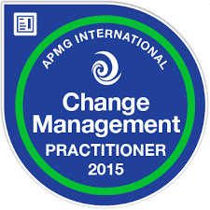

This session plan covers the delivery of the Change Management Foundation and Practitioner course, covering the full syllabus of the course, with additional material relevant to questions raised by delegates. There are activities throughout the course based on a specially created scenario/case study sent to you ahead of the course and you will be provided with the text book, The Effective Change Managers Handbook on which the syllabus is based, along with a pre-course reading guide.
As a result of this course you will be able to create a plan of an Agile Change initiative, defining the iterations of change, and be able to prioritise all of the change activities against the business benefits they create. You will be taken through the practicalities of building persuasive, influential stakeholder relationships and creating a culture for your change that inspires people to want to work differently.
Each session lasts approximately 90 minutes, with significant time per session given to activities and the sharing of the results of each of these activities. The times below are indicative and may run over if there are lots of questions.

Day 1 – Day 3 Foundation syllabus and exam preparation
- Session 1 - 9.15am to 10.45am
- Coffee Break 10.45am to 11am
- Session 2 - 11am to 12.15pm
- Lunch Break 12.15pm to 1pm
- Session 3 - 1pm to 2.15pm
- Coffee Break 2.15pm to 2.30pm
- Session 4 - 2.30pm to 3.45pm
At the end of Day 3 – FOUNDATION EXAM
- EXAM SESSION – online invigilation by Melanie starting at 4.30pm and finishing at 5.15pm

Day 4 – Practitioner preparation and revision
- Session 1 - 9.15am to 10.45am – based on “homework” using sample examination paper
- Coffee Break 10.45am to 11am
- Session 2 - 11am to 12.15pm – including work using sample examination paper
- Lunch Break 12.15pm to 1pm
- Session 3 1pm to 2.15pm
- Coffee Break 2.15pm to 2.30pm
- Session 4 - 2.30pm to 3.45pm – including work using sample examination paper
Friday morning – PRACTITIONER EXAM
- EXAM SESSION – online invigilation by Melanie starting at 9.30pm and finishing at 12.00pm
The format of each session is:
- Slide presentation of key points
- Review of key pages in the textbook, The Effective Change Managers Handbook, which is where the exam questions are drawn from
- Activity using scenario that mirrors the type of scenario used in the Practitioner examination.
- Open questions
- Review of work created by the delegates to share lessons learned
As this is an accredited examination course, the design principles for the activities are:
- They address the syllabus for the examination questions
- They use the specific text from the book upon which the examination questions are based
- They provide an activity that the delegate can use in their own workplace.
This is a diagram I usually draw to help us understand the flow of the course:
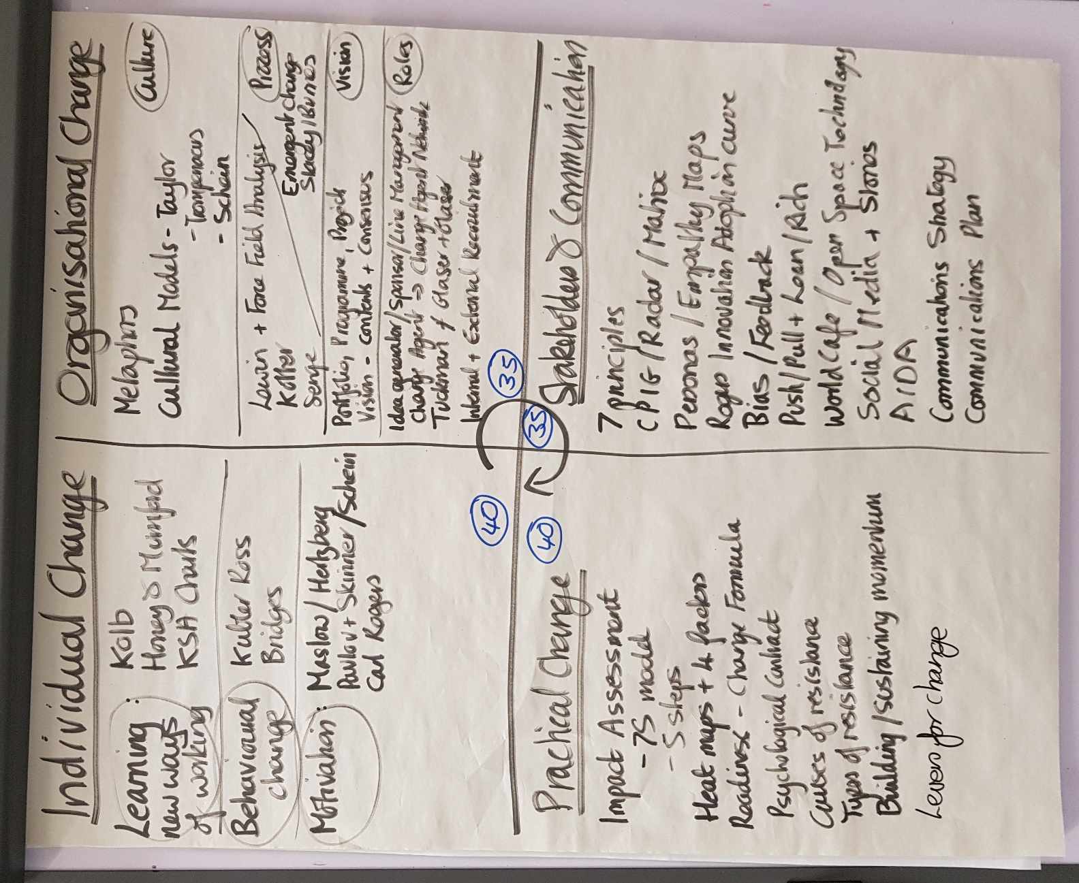

Change and the Individual

Session 1: Understanding Change Management
As a result of this session, delegates will be able to:
- Understand the differences between Delivery (project management activities) and Implementation (change management activities) and how they complement each other.
- Define projects, programmes and portfolio management and the importance of portfolio management in effective change management.
- Appreciate how individuals react to change using the Competency Model and Transition Curve (Kubler Ross and Adam's, Hayes and Hopson
- Complete an activity, using the scenario to work through the emotions on the Transition Curve.

Session 2: Change Management Lifecycle
As a result of this session, delegates will be able to:
- Understand the 3 phases of Bridge model of change and how we can use this model to lead people through the lifecycle of change.
- Identify the key messages needed for the Endings phase, working through examples.
- Complete an activity to prepare the information to announce change.
- Examine practical ways to identify and acknowledge the losses some stakeholders will experience as a result of the change.

Session 3: Learning Styles
As a result of this session, delegates will be able to:
- Understand how to engage people in the Neutral Zone of Bridges model through participation and sharing of experiences.
- Understand the different ways in which people prefer to learn new ways of working via the models of Kolb and Honey and Mumford.
- Compare these models with the MBTI personality preferences model and understand how these preferences impact on how people prefer to receive information about the change and participate in making the change a reality.
- Complete an activity to offer people the chance to participate in change according to their preferences.

Session 4: Motivation
As a result of this session, delegates will be able to:
- Understand each of the motivation models and what they have in common.
- Understand the importance of intrinsic motivation and how this aligns to leadership in the 21st century.
- Identify practical ways to identify how to find motivating factors for your change.
- Complete an activity to identify learning anxiety.

Change and the Organization

Session 5: Cultural metaphors and the “recipe” for cultural change
As a result of this session, delegates will be able to:
- Metaphors and practical examples of how this changes how we manage our change initiatives: who takes which roles, how we get approval for the change, how we engage people in the change.
- Understand the concept of Kotter’s dual operating system and how important this is for resourcing and managing change activities.

Session 6: Planned and Emergent Change
As a result of this session, delegates will be able to:
- Review the models of planned change: Kotter; Lewin: Senge and how they align with the Bridges three phases model.
- Complete an activity to use the Force Field Analysis technique.
- Review the concept of emergent change including the 4 steps of emergent change and what leaders need to do

Session 7: Roles
As a result of this session, delegates will be able to:
- Review the “standard” roles and the increasingly important subject of setting up a Change Agent Network.
- Understand the importance of the role of middle management and the conflicting emotions they can experience when leading change.
- Identify how to build teams using the Tuckman and Glaser and Glaser models.

Communications and Stakeholder Engagement

Session 8: Principles and Practical Tools
As a result of this session, delegates will be able to:
- We will review each of the 7 principles of effective communication and investigate practical ways to seek out stakeholders and keep on top of this task throughout the change lifecycle.
- Review the practical techniques for stakeholder identification and analysis: CPIG; Radar; Empathy Maps; Personas; Matrices
- Complete an activity to identify stakeholders for a change that you know well.

Session 9: Communication
As a result of this session, delegates will be able to:
- Understand 4 types of bias and how they impact the effectiveness of our communications.
- Define the importance of the feedback loop and review communication methods that generate feedback.
- Understand how to foster communication with large groups of people via Open Space Technology and World Café Techniques

Change management Practice

Session 10: Strategy and Plan
As a result of this session, delegates will be able to:
- Understand the contents of the Communications Strategy and Communications Plan.
- Understand the contents of a Change Management Plan and the alignment with the Communications Plan.
- Appreciate the usefulness of developing a Change Management Strategy.
- Complete an activity to develop your own checklist for the contents of your Change Management Strategy.

Session 11: Impact Assessment
As a result of this session, delegates will be able to:
- Understand the steps and the structure of a well planned Impact Assessment and how to put this impact into a wider context.
- Complete an activity to use the 7S model to complete an Impact Assessment.
- Understand the different types and causes of resistance to change.
- Complete an activity to plan your response to overcoming resistance to change.

Session 12: Foundation Examination Preparation
- This is a special session to review how to answer multiple choice style examination questions, and to review questions from each of the four sections of the course to ensure you are prepared for your exam.

Practitioner Preparation

Session 1 – Understanding the question types
As a result of this session, delegates will be able to:
- Understand what the examiner is trying to achieve with each of the question types used on the Practitioner paper
- Understand the answers and why they are the right answers for Q1 and Q2 of the sample Practitioner paper.

Session 2 – Communications and Stakeholder Engagement
As a result of this session, delegates will be able to:
- Have a chance to apply what they have learnt from Session 1 using Q3 of the sample paper
- Understand the answers and why they are the right answers via a review with Melanie.

Session 3 – Levers for change
As a result of this session, delegates will be able to:
- Identify the different levers for change
- Understand the Kelman model of compliance and how this affects our understanding of what change management must achieve.
- Appreciate the “Tipping Point” and how this aligns with Kotter’s 8 step model.

Session 4 – Communications and Stakeholder Engagement
As a result of this session, delegates will be able to:
- Have a chance to apply what they have learnt from Session 1 using Q3 of the sample paper
- Understand the answers and why they are the right answers via a review with Melanie.

