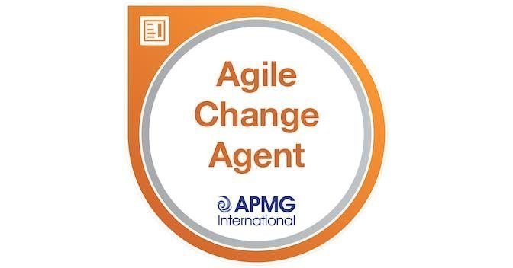

Overview
This session plan covers the delivery of the 2 day Agile Change Agent training course, covering the full syllabus of the course, with additional material relevant to questions raised by delegates. There are activities throughout the course based on a specially created scenario/case study sent to you ahead of the course and you will be provided with the text book Agile Change Agent on which the course is booked, along with a pre-course reading guide.
As a result of this course you will be able to create a plan of an Agile Change initiative, defining the iterations of change, and be able to prioritise all of the change activities against the business benefits they create. You will be taken through the practicalities of building persuasive, influential stakeholder relationships and creating a culture for your change that inspires people to want to work differently.
Each session lasts 60- 90 minutes, with significant time per session given to activities and the sharing of the results of each of these activities. The times below are indicative and may run over if there are lots of questions.

Day 1
- Session 1 - 9.15am to 10.45am
- Coffee Break 10.45am to 11am
- Session 2 - 11am to 12.15pm
- Lunch Break 12.15pm to 1pm
- Session 3 - 1pm to 2.15pm
- Coffee Break 2.15pm to 2.30pm
- Session 4 - 2.30pm to 3.45pm

Day 2
- Session 5 - 9.15am to 10.45am
- Coffee Break 10.45am to 11am
- Session 6 - 11am to 12.15pm
- Lunch Break 12.15pm to 1pm
- Session 7 1pm to 2.15pm
- Coffee Break 2.15pm to 2.30pm
- Session 8 - 2.30pm to 3.45pm
- EXAM SESSION – online invigilation by Melanie starting at 4.30pm and finishing at 5.15pm

The format of each session is:
- Slide presentation of key points
- Review of key pages in the text book Agile Change Management, which is where the exam questions are drawn from
- Activity using scenario/case study and checklists and questionnaires sent out as pre-course preparation
- Poll questions
- Open questions
- Review of work created by the delegates to share lessons learned
As this is an accredited examination course, the design principles for the activities are:
- They address the syllabus for the examination questions
- They use the specific text from the book upon which the examination questions are based
- They provide an activity that the delegate can use in their own workplace.
As pre-course preparation, delegates will have been provided with the Agile Change Management Handbook and a pre-course reading guide to read specific pages, which is the same as the face to face version of the course.

Session 1:
As a result of this session, delegates will be able to:
- Understand the differences between Delivery (project management activities) and Implementation (change management activities) and how they complement each other.
- Appreciate how the structure of the Roadmap brings these activities together to achieve a new way of working that can be adopted into operation use in the Realising Benefits step.
- Understand how the concepts of Agile approaches form the basis of change initiatives.
- Use the structure of a Roadmap to create a Change Management Plan, allocating time to two or more iterations.

Session 2:
As a result of this session, delegates will be able to:
- Understand how Iteration 1 defines the management approach for the change initiative.
- Appreciate the contribution that each of the 5 suggested documents developed in Iteration 1.
- Describe a change using the Scope/Exclusions structure.
- Understand how Iteration 2 is used to structure the creation and testing of new ways of working.

Session 3:
As a result of this session, delegates will be able to:
- Understand the definitions of benefits, requirements and acceptance criteria.
- Identify the difference between requirements led and benefits led change.
- Identify how benefits are used as a key control for the project.
- Create a Benefits Dependency Network and understand how to workshop this with others.

Session 4:
As a result of this session, delegates will be able to:
- Use your understanding of organisational capability and market context to trigger the identification of benefits.
- Take the Motivation Questionnaire to assess if the benefits are strong enough to justify the effort of the initiative.
- Design a Benefits Workshop, creating the activities and agenda for the workshop and identifying who to involve.

Session 5:
As a result of this session, delegates will be able to:
- Use the Community Map to identify the key relationships needed to implement and adopt their change initiative.
- Appreciate their own work preferences and how these align and differ with those that they seek to influence.
- Understand the five elements of personal leadership.

Session 6:
As a result of this session, delegates will be able to:
- Identify actions that will develop their own personal leadership across these five factors.
- Understand the importance of resilience in leading change initiatives and identify situations in which they feel most tested and ways in which they can build their own resilience.
- Understand the importance of empathy when trying to persuade others to adopt a new way of working.

Session 7:
As a result of this session, delegates will be able to:
- Understand what is meant by environment, how it relates to organisational culture and its constituent parts.
- Identify the ways in which environment must provide reassurance, including the fears triggered by change.
- Explain why encouragement is important and the links to a positive environment and its benefits.
- Understand the elements of intrinsic motivation and how to achieve this for all those involved in the change initiative.

Session 8:
As a result of this session, delegates will be able to:
- Brainstorm the conditions for an effective environment for change using the elements: Approach, Authority and Ability.
- Understand how the conditions for an effective environment are captured in the Change Management Strategy.
- Review the exam technique needed for successful completion of the Agile Change Agent qualification

Follow up
- Take the sample paper and review the answers with the trainer by phone/email.

