Top tips for creating successful change !

Author
Melanie Franklin
Director
Agile Change Management Limited

Introduction
One of my greatest challenges when transferring my knowledge about how to manage change is “where to start?” Change management is a vast subject and there are so many aspects, it is not always easy to know what the most useful information and examples will be to share.

For this paper, I went direct to the source, and asked those who are “non-professional” change managers, working in other roles in the business, but expected to lead change from within their teams what they wanted to know about.

All those I asked identified common issues that make the move to new ways of working difficult to achieve and stressful to lead. The most frequently cited examples are:

- No-one I work with understands why we must do this change
- Everyone is too busy with other changes
- No-one is helping me make the change happen

These issues are not experienced in isolation. If people do not understand why the change is important, then it will increase the probability that they are too busy, because they will not sacrifice other work to create capacity for taking part in the change.

If people are too busy to take part in the change, then you will not have anyone helping you to make the change, similarly if people cannot see the value of making the change happen (what is in it for me?) then they will not help you to create new ways of working.

This paper is designed to help all of you who are being asked to implement change at work. If you are new to the subject, no prior knowledge is assumed. For anyone who is already leading change, this will be a useful refresher. I have included as much practical help as possible, but if you want more help, keep in touch for regular lessons learned from my change initiatives.

No-one I work with understands why we must do this change
Change can only happen if those who need to work differently commit to doing so and in sufficient numbers. We know that not everyone is open to change, and our challenge is to get the support of those who would prefer to keep things as they are.

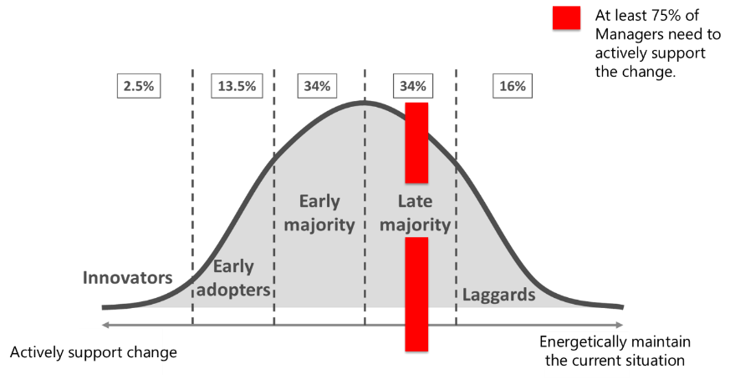
Copyright © Melanie Franklin 2019
This is the visual I have in my head when I think about how persuasive I need to be. It highlights the point from Professor Kotter and others, that change will only work if a sizeable majority support it.

To be a successful change manager means mobilising the effort of all those impacted, and the first step to achieving this is create a willingness to change.

This willingness is not generated by enthusiasm for organisation wide benefits. People do not get excited by claims that the change will help to achieve strategic objectives. Unless they are a board member, these are too far removed from their own responsibilities to have much meaning.

Enable people to discover the value of the change for themselves
We need to help people to discover how the change will make a difference to the things they care about. For example:
- Does the change fix a current problem that makes their work harder to do?
- Does the change offer a simpler, easier way to get things done that might save them some time?
- Does the change do something that they think is important?
- Does the change make them feel that they are offering a better level of service?
- Does the change enable them to develop their skills?

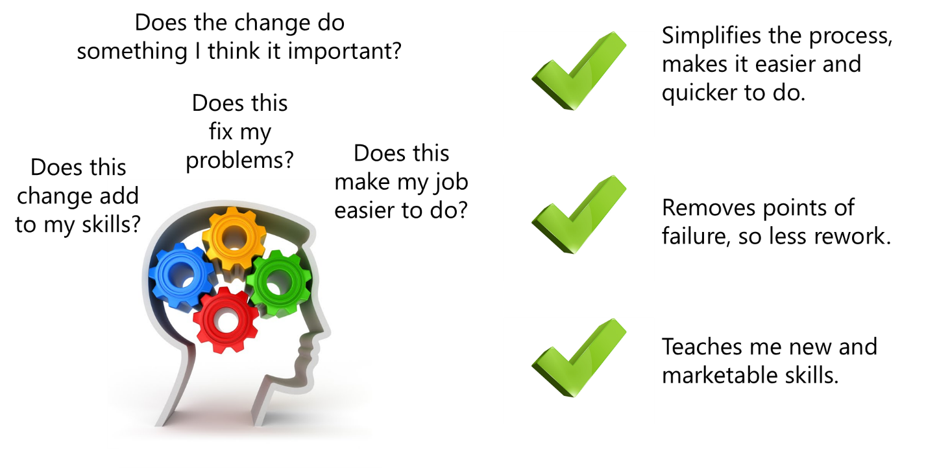
Copyright © Melanie Franklin 2019

To create this realisation, we need to give people plenty of time to talk, to compare what they do now with the changes and work out for themselves what the differences will be and how these might be an improvement. To give some structure to these conversations, I keep in mind the factors in the Beckhardt and Harris Change Formula, as they provide an agenda of questions I can ask:
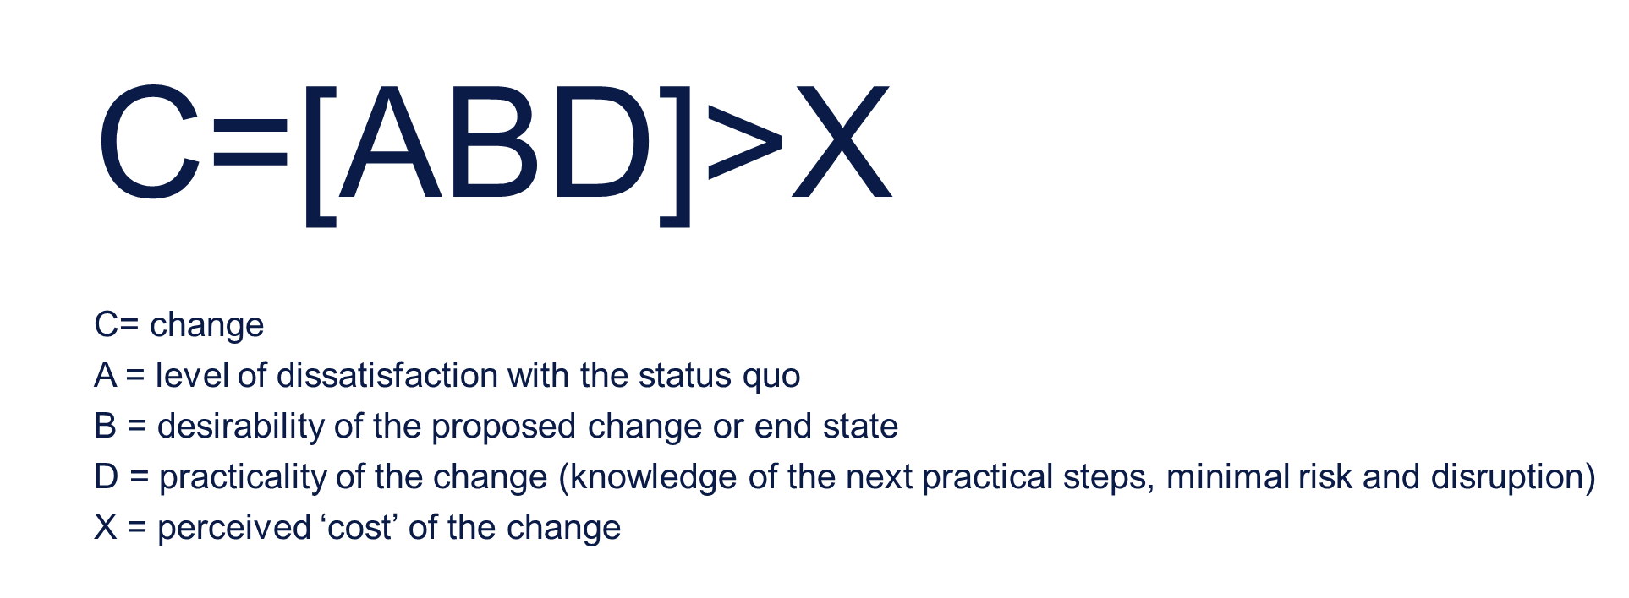
The key thing is to engage in conversation because it is in the sharing of views and experiences that people will find their own motivation for the change. Ask:
A = what are the problems and issues you experience today? Generate discussion about things that don’t work, that are harder than they need be to do, where people think they are doing things that are not necessary or are a waste of their time, or areas where others complain about the quality or the service of something.

All these statements help to chip away at those that believe “we are fine as we are” by drawing them back to reality, that everything currently is not perfect and is therefore not worth preserving in totality.

B = Ask people why they think the change will be an improvement, and what are the things that they are most looking forward to having in place. Ask them why they think things will be better and get them to share examples of how this might occur in practice. This gives you stories to tell to others which generate excitement and enthusiasm.

D = Ask what resources those impacted by the change need to help them make the transition to new ways of working. Describe the support available in detail, so that people can imagine themselves engaging with it, which makes it more real and therefore more reassuring. For example, if you are planning a training programme, or you are going to hold a series of demonstrations to explain the change, tell people as soon as you start planning these events, so they can feel reassured by the amount of information available to them.

Remind everyone that not everything is changing
We also need to give them reassurance by making sure that any enthusiasm they have for the change is not overwhelmed by the feeling that the change is so big that it is going to totally disrupt their work.

To achieve this, talk about the change in terms of what they have now, to make it clear that not everything is changing. If you can align the change to how things currently work, which everyone is familiar with, then they will not feel that it is such a giant leap and can work out for themselves the scale of the adjustment they need to make.

After all, it is that familiarity with the present which provides comfort and confidence, so don’t throw it away by only talking about what is going to change. If you do, you are pinning all your hopes on people becoming so excited by the possibilities offered by the change that they will forget the difficulties of learning a new way of working and fear of losing what is known and understood today. That is quite a lot of pressure to put on your ability to market the benefits of your change!

Keep it simple, by talking about any change you want to make using this formula:
- What we currently do that we will still do
- What we currently do that we will no longer do
- What we are going to add to what we are doing
This enables everyone to see how a lot of what happens today will still be retained, which helps them manage their stress by realising that their current skills are still relevant. Whenever I have to talk to people about change, I start the conversation by explaining what will NOT change.

This might sound counter-intuitive, but change is a stressful word. It implies giving up existing habits, no-longer feeling confident about how to do things. I want to provide reassurance and encouragement, and that comes from reminding people of what they do today, how good they are at it, and what positive impact it makes.

I can then talk about how the change builds on this, or gets rid of known problems or difficulties, always creating the view that the change is a positive move, not a destruction of everything that they have built up.

Everyone is too busy with other changes
No change takes place in isolation. What we do, how we do it, and who we do it with are constantly changing. One of the biggest issues we have today is the high volume of change. This diagram explains the problem: change is a product of other change, and as the sources of change continue to speed up, every area of business has to react with yet more changes.

These key sources of change include: IT, customer demand and the regulatory landscape. Each change that is triggered creates pressure on related areas of the business to operate differently to take advantages of the opportunities (disruptive change) or to continue to operate by aligning to what has changed around them.

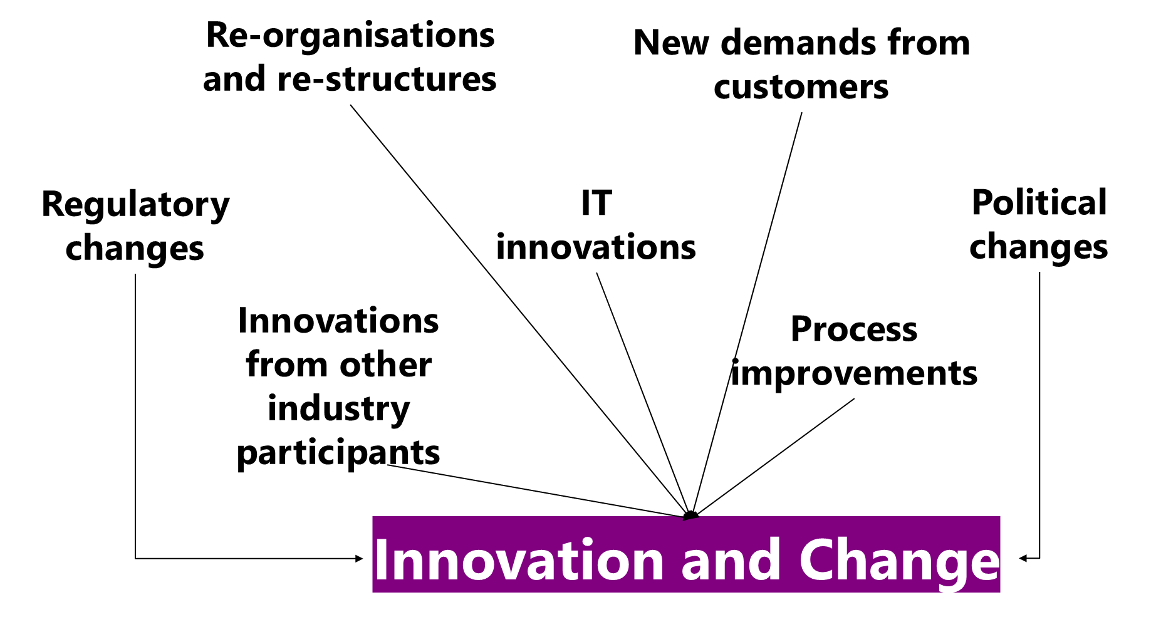
Copyright © Melanie Franklin 2019

This means that when we turn up for work, there is a good chance that our certainty about how to do our job is going to be challenged. We will need to spend time and mental energy changing something that used to be an automatic reaction. We must remember not to work the old way, and start working the new way, learning as we go, making mistakes and trying to fix them. All within an environment of continued pressure to perform and achieve.

The metrics that measure our performance don’t take a break whilst we are trying to learn new ways of working, so we feel stressed, which makes it harder to learn, which slows us down which makes us feel more stressed!

Create a holistic picture of change
In this tense environment, being the person who has to introduce yet more change isn’t a short cut to popularity. My coping strategy is to make sure that any change I am asking people to make is not described in isolation. I need to acknowledge that everyone already feels caught up in many other changes, otherwise I am ignoring the reality of the workplace, and that means I will not be trusted.

My answer is to describe how the change I am asking for aligns to all the other things that are happening so that everyone can see for themselves how it fits in. This is important, because when people are already very busy, they are less likely to put effort into something that doesn’t connect to what they are already trying to achieve.

If my change appears to be taking them off at a tangent, then why would they want to help me? I need to create an integrated picture of change, that links the change I am trying to implement with everything else that is going on:

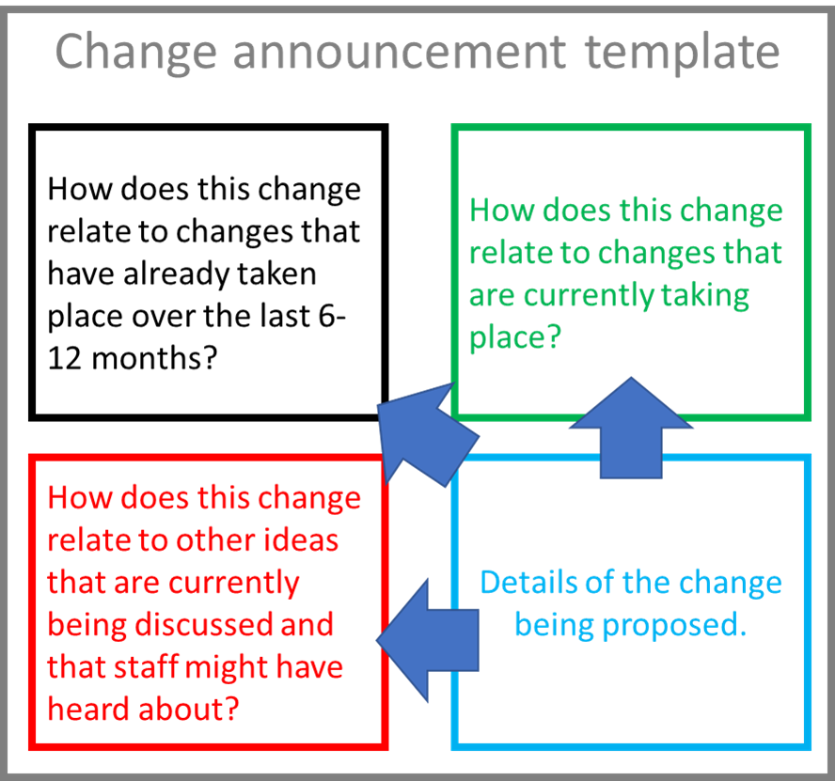
Copyright © Melanie Franklin 2019

This is not easy, because it requires me to assimilate a lot of information and create an integrated picture of change. To do this I need:
- Portfolio of initiatives
- Network of other change managers
- Ability to explain the knock-on effects of one change on another
- Balance requests for change with capacity building

Portfolio of initiatives
If I am lucky, there will be a portfolio of all initiatives that are currently underway or planned but not yet started. This might be at the department or division level or might be organisation wide.

A portfolio outlines what else is happening, but it will not be complete as it is unlikely to include every little tweak to current processes that teams are making to continually improve how they do things. However, it is a starting point for providing context for where the change you are promoting fits in with a bigger picture.

The advantage of referring to other things that are happening is that it connects people to information they are already familiar with and creates the impression of a cohesive transformation to how things are done, rather than an unconnected, piecemeal approach.

It also helps to reinforce the message that change is continuous, and that your change is part of a flow, so deciding to opt out and not help the change become a reality doesn’t serve any purpose, because the next change that comes along will rely on these changes. Failure to adopt one change builds a backlog of things that still need to be addressed, which creates an emotional pressure for getting involved in the change.

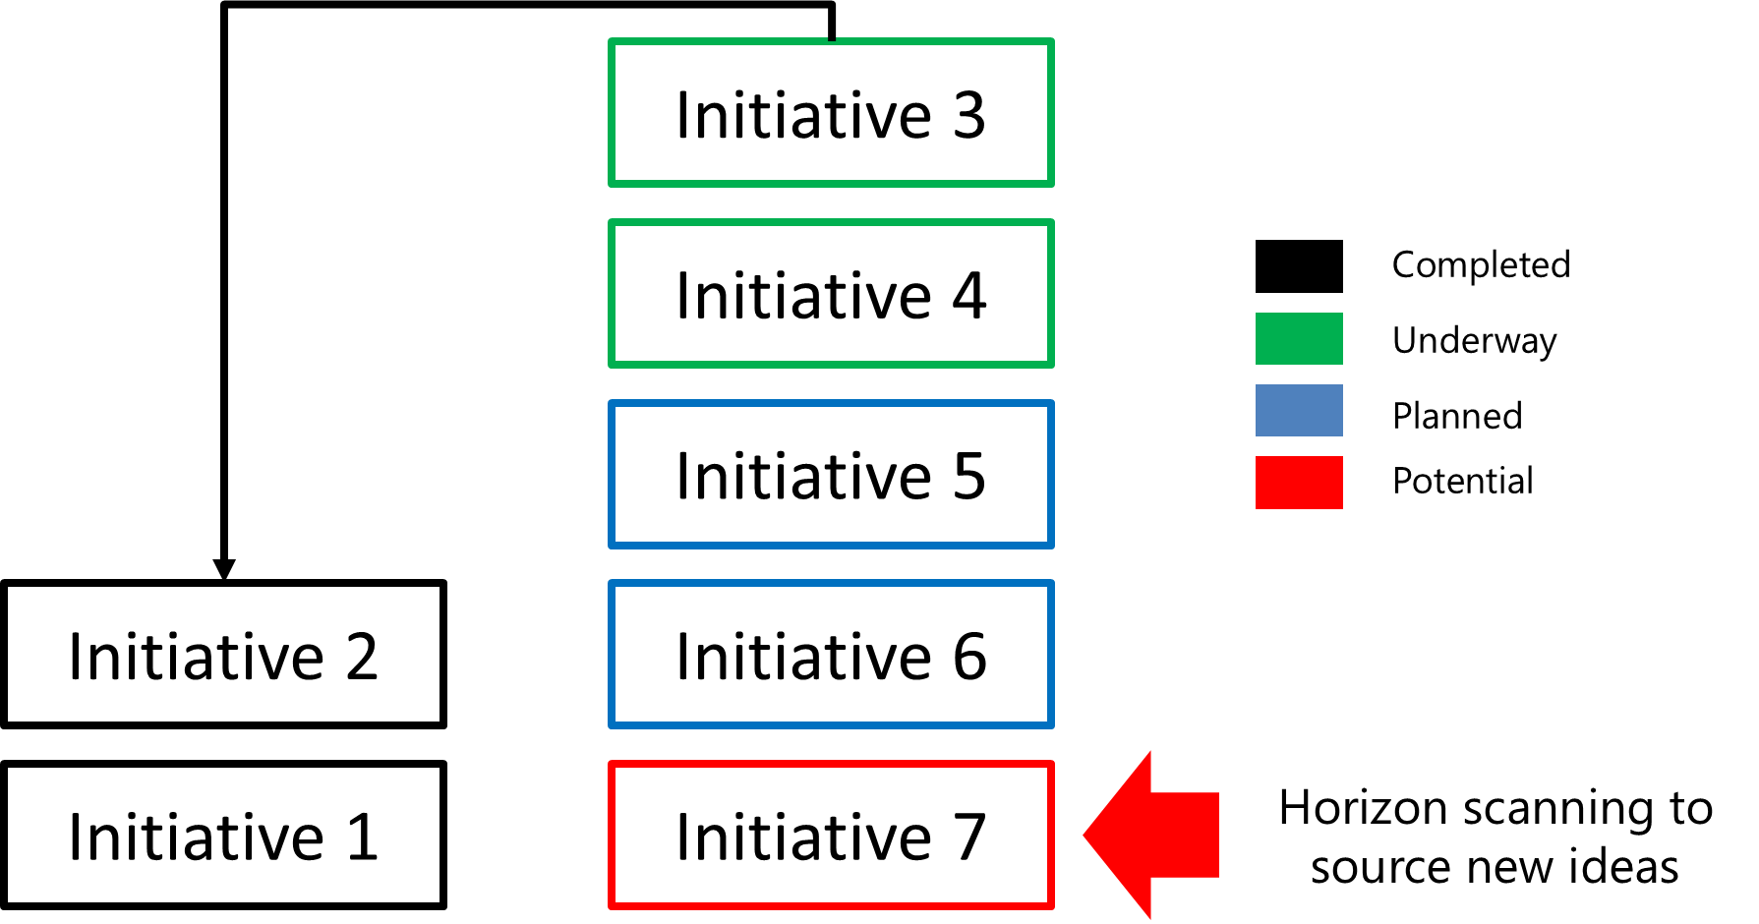
Copyright © Melanie Franklin 2019

Network of other change managers
For the “official” change initiatives that appear in the portfolio, as opposed to the smaller, local improvements, it is a good idea to make friends with those in the project teams so you can understand what changes they are creating, and how this impacts on the change you are trying to achieve.

Get in the habit of openly sharing your scope of work, your plans for when deliverables will be available, when training and demonstrations are being held and when things are expected to be up and running as new ways of working. Exchange this information with other Change Managers and team leaders who are implementing smaller-scale, less formal changes in their teams.

Ability to explain the knock-on effects of one change on another
Depending on your preference, you might be good at talking through the implications of one change on another, or you might find it useful to draw pictures to show how one thing is connected to others.

Whatever your preference, this is an important step for two reasons:
- It challenges you to make sure you are clear about the impact of your change, and how it triggers change elsewhere in the business.
- It helps all those impacted understand what they need to change and if they do not, how it will hold up other, related changes.

Balance requests for change with capacity building
Change requires more work and more effort when everyone is already over-committed. Make sure that when you ask people to do things differently, you ask them at the same time what they can stop doing to create enough time to spend on the change. Encourage people to be ruthless with their time, stop doing things “because we always have” or because “if I don’t do it, it will not be done properly”.

If we have a disaster at home, our washing machine floods the house for example, however busy we are we take time to clear up the mess, call in the plumber etc. When there is sufficient motivation, we can always find things to stop, and that is the mindset we need to create sufficient capacity for change.

People find this conversation empowering, because it turns them from the victim of change into someone who is taking charge of their own world. You will only get these answers if you are prepared to ask lots of questions and work with someone through their typical day or week, to find those things that when asked to explain them, the person realises they don’t know why they do them or realises that they don’t really add much value.

No-one is helping me make the change happen
A change becomes the new way of working when more people are working in the new way than are working in the old way. The number of people impacted by a single change means that it isn’t possible to make a personal connection with everyone who needs to change. It is better to create a network of supporters who can influence those they are closest to start working differently, by role modelling the change and showing others how to do it.

Use lessons learned from our earlier points to get the messages right
To get the most out of this network, you need to make sure that the messages they are spreading to others in their sphere of influence are addressing the issues of willingness to be involved, and can overcome busyness at work. So make sure they are doing what you do, and encourage people to find what they can stop, before they start making change happen. Encourage them to realise that not everything is going to be changed, there is a lot of what they do today that will remain the same. And help them to create a cohesive picture of the change, so it doesn’t feel as if the change is going in a different direction to what has already been asked of people.

Create intrinsic motivation
This means bringing together a voluntary group of people who are inspired by the change, can see its benefits and want to adopt the new way of working. It is their enthusiasm for the change that will persuade others in their sphere of influence to start working in new ways.

Offer a menu of ways that people can contribute so that they have the power to choose what they do, how much they do, when and how they do it.

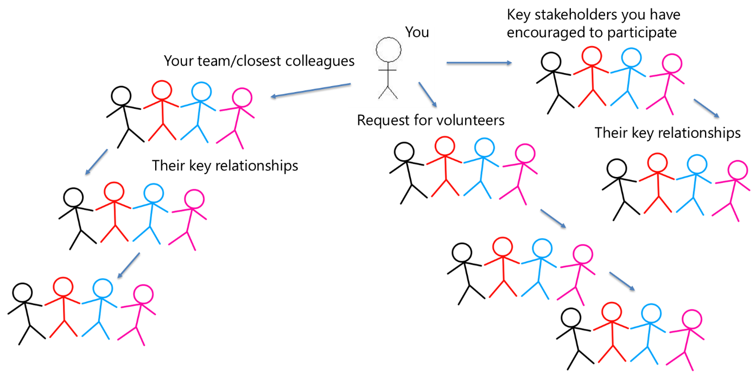
Copyright © Melanie Franklin 2019

As this is a voluntary role, it is important to allow people to decide for themselves what they think they need to do, and to bring them together with other like-minded colleagues to get a consensus on the role and its responsibilities.

This empowerment needs to extend to what they do and how they do it. For example, in some situations, your “change champions” will be most effective as super-users, who have become heavily involved in the training for the new ways of working and are keen to share their knowledge with their colleagues. Alternatively, your “change champion” is better as a role model for the change, developing new ways of working and applying them to their role, demonstrating that the change is possible and that it is beneficial.

As everyone has different skills, talents and preferences, facilitate discussion amongst your network about what they are doing, and what is working well, so they can share their experience and develop more ideas. This means they are a self-directed group, you do not manage them, but you help to network them and provide the conditions for their collaboration.

To give this discussion some structure, I like to use a KSA chart as a starting point. KSA stands for Knowledge, Skills and Attitudes. It is a great tool for workshopping with all those involved, as each column generates ideas and discussions.

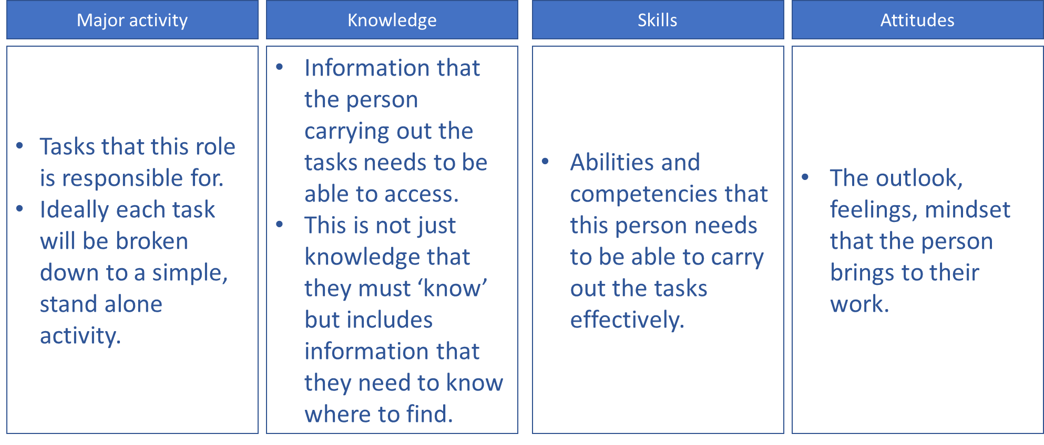
Copyright © Melanie Franklin 2019

Conclusion
The three issues I have talked about in this paper are common to all change initiatives. We are all facing the same problem of too much change and not enough time to adjust before the next change needs to be implemented. I hope this paper shows that by keeping our message simple, recognising the pressure that people are under and giving them opportunities to voluntarily participate we can create a movement of enthused, engaged colleagues sharing the same goal.

About the author
My job is to help organisations develop the capability to manage change and transformation. This involves a wide range of activities as no two organisations are the same. For example, devising frameworks and toolkits to build capacity for change and Agile working, or supporting senior leaders to become effective Sponsors through workshops and coaching.

I love my job so much that I write lots of articles and books to help transfer my knowledge and experience to the next generation of change managers. I am passionate about my profession and help to lead the growth of the Change Management Institute in the UK as well as promoting our professional globally.

To access more resources about change management, sign up for my newsletter or connect with me on LinkedIn https://www.linkedin.com/in/melaniefranklin1

